Qingdao Xingfu Energy Equipment Co., Ltd.

Technical parameters of 600,000Kcal HOT AIR STOVE
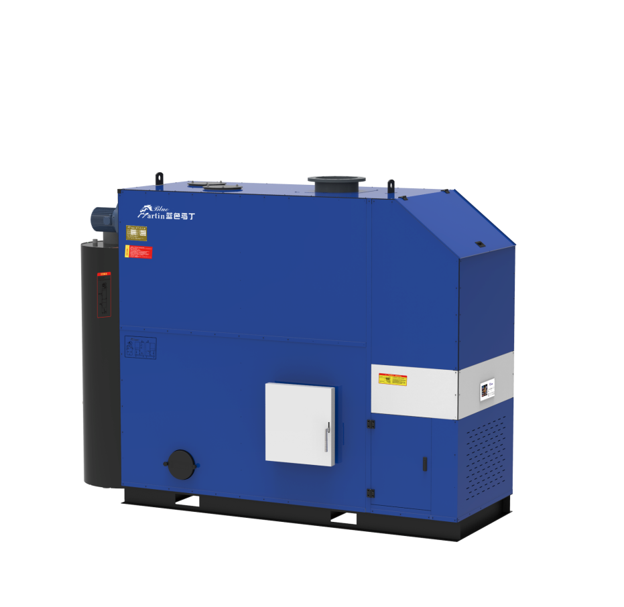 | model | FWHS-0.7
 | Pressure of work | pressure
 | The thermal efficiency | 93%
 | Rated calorific value(万Kcal) | 60
 | Circulation fan | 5500
 | The rated voltage(v) | 380V
 | Induced draft power(w) | 1100
 | Blower power(W) | 550
 | The chimney diameter（mm） | 273
 | fuel consumption (kg/h) | 143
 | Size(mm) | 2800
 |  | 1200
 |  | 2550
Standard configuration:  Hot air stove 1set | Shipping Weight(kg) | 2370

