Qingdao Xingfu Energy Equipment Co., Ltd.

Technical parameters of 300,000 HOT WATER BOILER
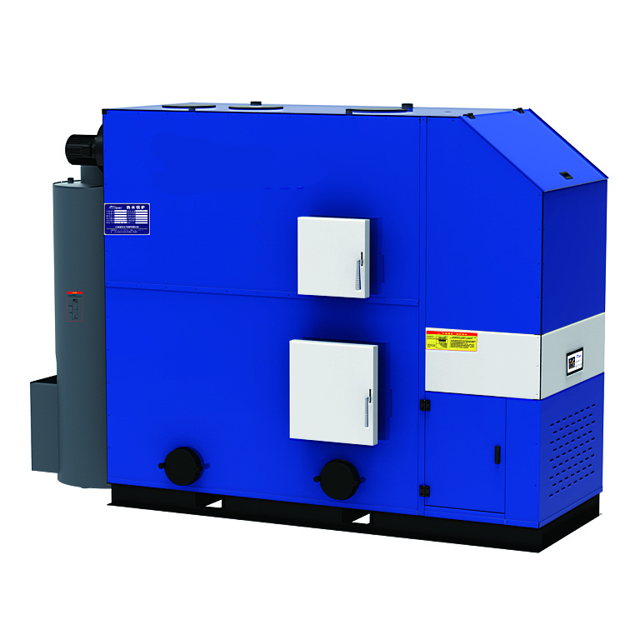 | Mode | CWHS-0.35
 | Working pressure | Normal pressure
 | Heat efficient | 93%
 | Rated thermal power | 30×10⁴kcal
 | Heating area | 3000㎡
 | Rated Voltage | 220V
 | Induced draft fan power | 750W
 | Blower power | 500W
 | Chimney size | 165mm
 | Water flow | 7.5T
 | Water inlet diameter | 76mm
 | Dust Collection | Φ480×1600
 | Fuel consumption | 57kg/h
Standard configuration:  Boiler body 1set, Auto control panel 1set, Feeding system 1set , Dust collector 1set , Blast fan 1set, ID fan 1set, Valves and instruments , 1unit Water pump 1set. | Boiler size | 2230mm
 |  | 1100mm
 |  | 2100mm
 | Silo size | Integrated Design of Boiler and silo
 | Transport weight | 1800kg

